4CS015
FUNDAMENTALS OF COMPUTING
PORTFOLIO-3

Name: -Rohit Sahani
Student Id: -NP02CS4A250027

# Load the following program into the simulator:
LOADTEMP
ADD
LOADTEMP
ADD
DISPACC
HALT

What do you think it does? Write your answer below (10 marks) (Make sure you include details of what is happening at every program pointer position to get full marks, you can include screenshots as well as descriptions to help illustrate your answer
This program is executed by a simple accumulator-based processor with a moving program pointer. First, it enters the first position of the program pointer and carries out a LOADTEMP, which stores a copy of the contents of memory location TEMP into the accumulator, ACC. The program pointer advances one space, pointing to the ADD instruction, which adds a copy of the contents of memory location TEMP and those of the accumulator, and then doubles the contents of ACC, which now has a double quantity of TEMP. The program pointer advances one space further, pointing at the LOADTEMP instruction, which now wipes out the contents of ACC with its previous contents, now in memory location TEMP, thus discarding any previous calculation results. The ADD, once more, at the fourth step, adds a copy of the contents of memory location TEMP into ACC, obtaining a double of TEMP. Finally, when the program pointer points to DISPACC, the current value of the accumulator gets displayed as output, hence it displays double the value held in the memory location TEMP. Lastly, at the last position of the program pointer, the instruction HALT halts the execution of the program.

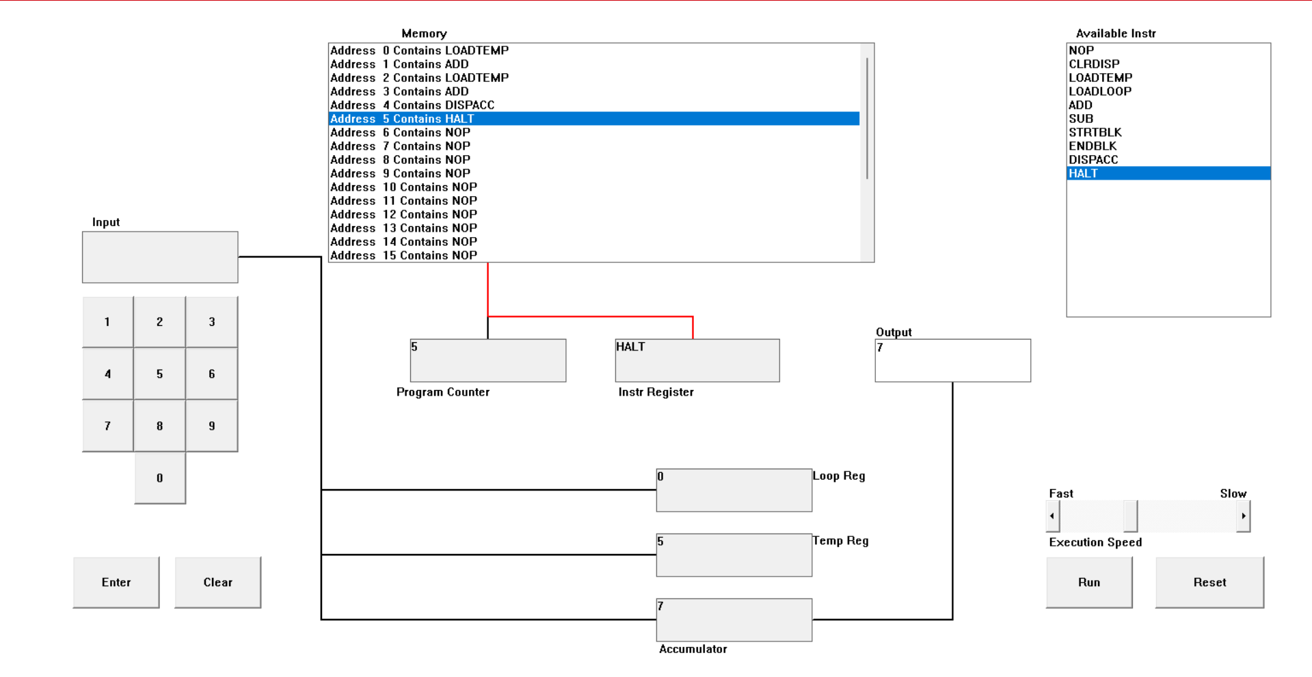

Description
LOADTEMPCODE, the accumulator is left with 2. Next, the ADD statement followed by the addition of the next number entered, that is, 5, gives the accumulator the value 7. Then, the LOADTEMPCODE statement follows, which loads the current number from the TEMP space, but since the addition process is completed, the accumulator holds the result of such an addition. Eventually, the DISPACC statement causes the output 7 to be displayed, followed by the HALT statement that stops the execution of the entire process. Thus, the net result that the entire
process gives is the addition of the two numbers that I have entered, namely 2 and 5, both resulting in an output of 7.
  - Write a program to add 3 different numbers together. List your program below (10 marks)
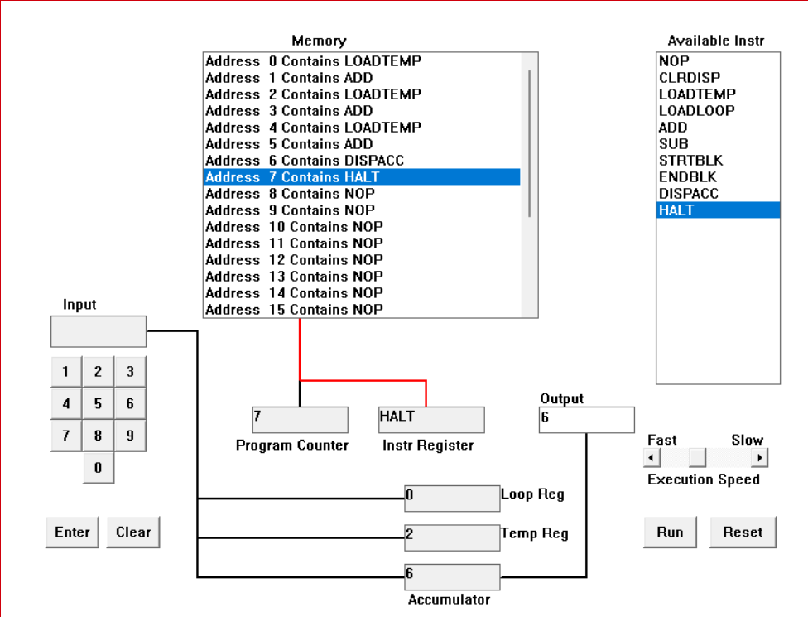
Output: -
LOADTEMP
ADD
LOADTEMP
ADD
LOADTEMP
ADD
DISPACC
HALT

Description
* I begin with 0 in the accumulator.
* Then, I entered the first number, 2, into TEMP. Then, by the operation of LOADTEMP, it enters the accumulator, and ADD adds TEMP to it. In this way, the first number enters the accumulator.
* Next, again storing 2 into TEMP and then carrying out the next operations: LOADTEMP and ADD. Thus, it adds this number to the accumulator.
* Then again storing 2 into TEMP and then carrying out the next operations: LOADTEMP and ADD. Thus, it adds this third number to the accumulator.
* And at last, DISPACC shows me the result – 6 – and then HALT halts it. This code properly adds three different numbers by sequentially storing and then adding those values from TEMP to the accumulator.
  - Write a program to subtract a number from another number. List your program below (10 marks)
Output: -
LOADTEMP
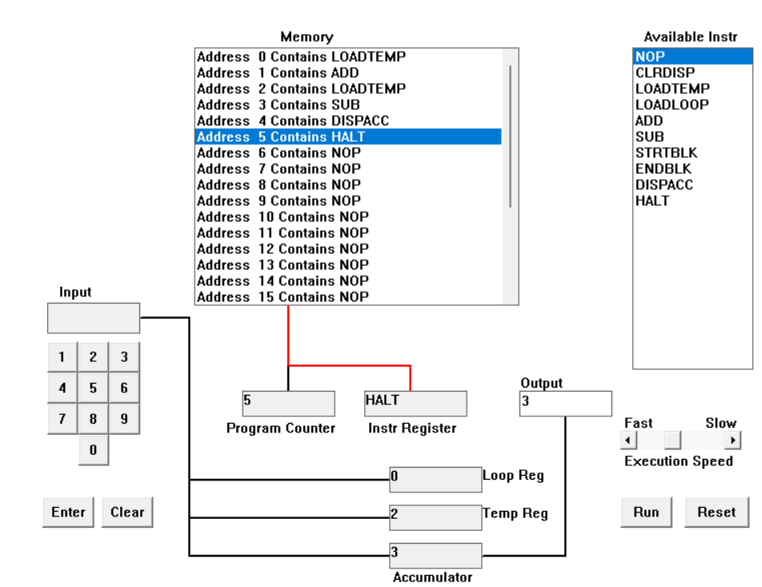
ADD
LOADTEMP
SUB
DISPACC
HALT

Description
Originally the accumulator register has 0 in it. The first number 5 is put in TEMP and the operation LOAD TEMP puts it in the accumulator. Now we have ACC = 5. The second number 2 is entered into TEMP, and the operation SUB deducts the value in TEMP from the value in the accumulator. Now we have ACC = 5 - 2 = 3. Lastly, the operation DISPACC enters the value 3 into the display register and terminates the program by executing the operation HALT. The program will then subtract the second number from the first and enter it into the display register.

  - Load the following program into the simulator:
LOADTEMP
ADD
LOADLOOP
STRTBLK
ADD
DISPACC
ENDBLK
HALT
Run it and when it reaches the LOADTEMP instruction, enter 5 on the keypad and click the “Enter” button. When it reaches the LOADLOOP instruction, enter 6. What do you think the program does? Write your answer below in the form of an equation (10 marks) (Make sure you include details of what is happening at every program pointer position to get full marks, you can include screen shots as well as descriptions to help illustrate your answer)
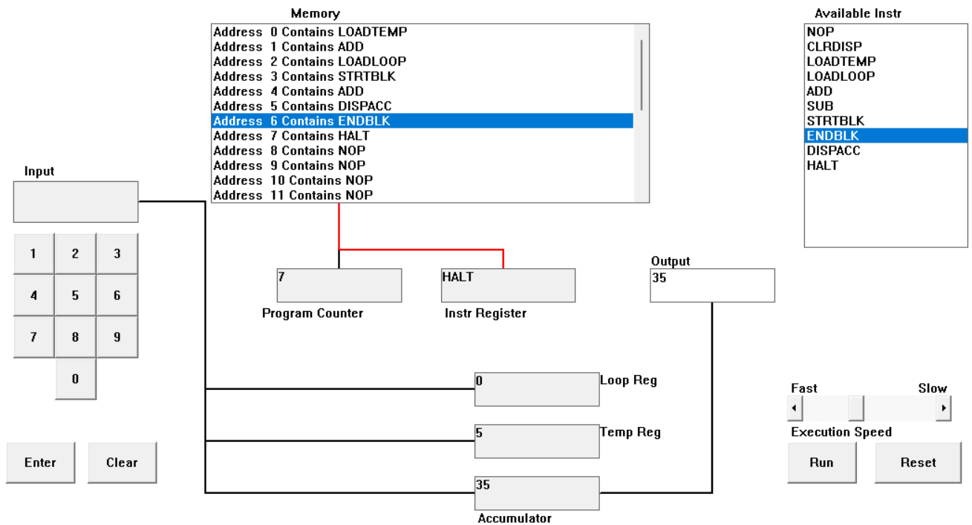
Description
It starts with storing the first input number of 5 in the temporary register and then transferring it to the accumulator to begin the process. The program proceeds to use the second input number of 6 as the loop counter. When the loop is entered, the process continuously increments the accumulator with the value 5 each time through all six times. On the other hand, the display is updated to reflect the cumulative sum. Once all the six times are completed in the loop process, the sequence ends with all operations halted while the final calculated sum of 35 is frozen on the display screen.

Execution Trace by Program Pointer
This is a step-by-step description of how each pointer location contributes to getting a result of 35:
* Pointer 0: LOADTEMP (Value
The program calls for the entry of the first number using the keypad. The entry of 5 enters it into the Temporary Register. The number entered is the base number which will be incremented by addition.
Pointer 1:
In this assembler operation, the data in the Temporary Register (5) gets added to the Accumulator (which contains 0 initially). In this phase, the value in the Accumulator is 5.During this phase, the Accumulator holds the value 5.
*Pointer 2: LOADLOOP
The program pauses to take the second input. Pressing 6 will give the Loop Register the value 6. This means the simulator will execute the next block of instructions 6 times.
*Pointer 3: STRBLK
It is the start of the loop cycle. The processor is ready to start the process of all code from here to the instruction ENDBLK, a number of times determined in the Loop Register.
*Pointer 4: ADD
Inside the loop, this adds to the Accumulator the value which is in the Temporary Register (5). The loop repeats 6 times. So, 5 + 5 + 5 + 5 + 5 + 5 is added to the initial value of 5.
*Pointer 5: DISPACC
It prints out the current value in the Accumulator on the screen. It is a process that is contained in a loop in this particular set of instructions; hence you can observe the numbers "climb" (10, 15, 20.) until the final tally.

*Pointer 6: ENDBLK
This completes the loop. The program checks the Loop Register; if it has not finished the 6 cycles, it jumps back to STRTBLK (Pointer 3). When completed, the Accumulator total will be 35.
*Pointer 7 HALT
It halts all activities and leaves the final answer of 35 on the screen.
d. Write a program that will let you add five different value numbers together. List your program below and explain how it works (25 marks) (Make sure you include details of what is happening at every program pointer position to get full marks; you can include screen shots as well as descriptions to help illustrate your answer.)

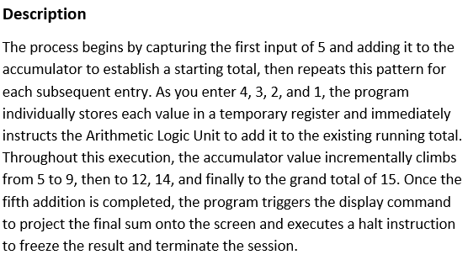
Output: -
LOADTEMP
ADD
LOADTEMP
ADD
LOADTEMP
ADD
LOADTEMP
ADD
LOADTEMP
ADD
DISPACC
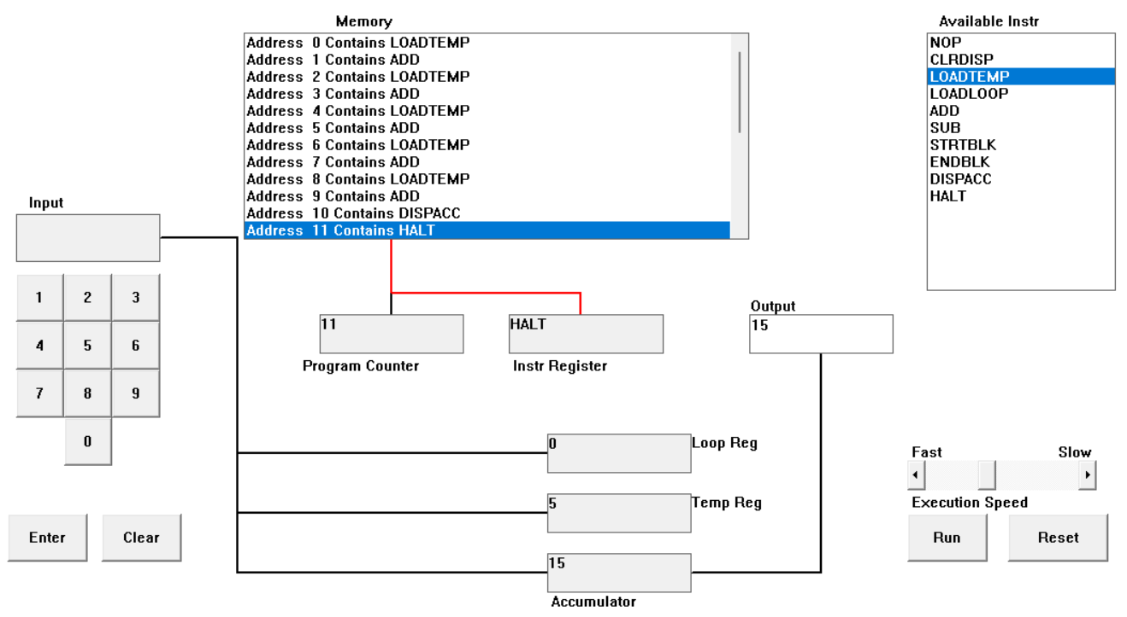
HALT
Execution Trace by Program Pointer

• Pointer 0: LOADTEMP example de code: LOADTEMP (Enter: 5)
The program initiates the input cycle. You enter 5. It moves the data from the keypad buffer into the Temporary Register. The Accumulator stays at 0 on this first fetch.
•Pointer 1: ADD
The Control Unit directs the ALU to perform an addition of the Temporary Register and add that amount to the Accumulator. The value within the Accumulator changes from 0 to 5.

• Pointer 2: LOADTEMP/Input:4
The program halts for a second user input. Inputting 4 overwrites the Temporary Register's value. The Accumulator remains at 5 with the first value.
- Point 3:
The operation 5+4 performed on the ALU. The ACC register is set to 9 which corresponds to the sum of the previous two inputs.
- Pointer 4: LOADTEMP -Input 3
The third input cycle starts. The entry of 3 sends the value into the Temporary Register. The previous running total - 9 - is saved in the Accumulator.
- Pointer 5: ADD
The ALU fetches the 3 from the Temporary Register and adds it to the 9 in the Accumulator. The new running total becomes 12.
- Pointer 6: LOADTEMP (Input: 2)
The program prompts for the fourth value. Entering 2 updates the Temporary Register. The Accumulator remains at 12.
- Pointer 7: ADD
The ALU adds the 2 to the existing 12. The Accumulator's state is now updated to 14.
- Pointer 8: LOADTEMP (Input: 1)
The final data-entry phase occurs. Entering 1 fills the Temporary Register for the last time. The running total in the Accumulator is currently 14.
- Pointer 9: ADD
The processor executes the final addition. The value 1 is added to 14, resulting in a final internal total of 15 stored in the Accumulator.
- Pointer 10: DISPACC
This is the output instruction. The processor takes the binary value of 15 from the Accumulator and converts it to a decimal display on the simulator's output screen for the user.
- Pointer 11: HALT
The Program Counter stops incrementing. The CPU sends a termination signal to the clock, ending the execution and ensuring the result of 15 remains static on the screen
• Pointer 6: LOADTEMP (Input
The program prompts for the fourth value. The entry of 2 changes the Temporary Register. The Accumulator still holds 12.
• Pointer 7:
The ALU performs addition of 2 to the existing 12. The state of the Accumulator changes to 14.
• Pointer 8: LOADTEMP
The final stage of data entry starts. Pressing 1 enters 1 into the Temporary Register for the last time. The running total in the Accumulator is 14.

• Point 9: ADD
Executes the final addition. The number 1 is added to the number 14, giving a final internal sum of 15, which is stored in the Accumulator.
- Pointer 10:
This is the output statement. In the processor execution, the processor works with the binary number 15 from the Accumulator to produce the decimal display on the output screen of the simulator.
• Pointer 11 HALT
The Program Counter ceases to increase. The CPU transmits a signal of termination to the clock. This brings the execution to a halt and freezes the value of 15 on the screen.
e. Write a program that will let you multiply two fixed-value numbers together. List your program below and explain how it works (35 marks) (Make sure you include details of what is happening at every program pointer position to get full marks; you can include screen shots as well as descriptions to help illustrate your answer.)

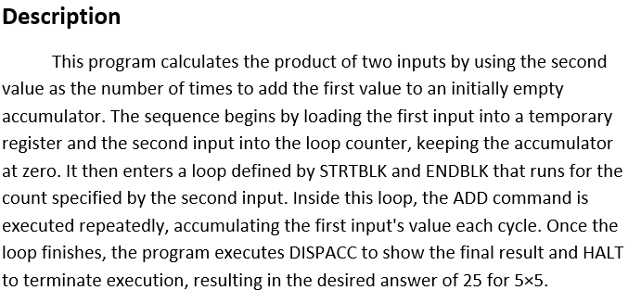
Output: -
LOADTEMP
LOADLOOP
STRTBLK
ADD
ENDBLK
DISPACC
HALT
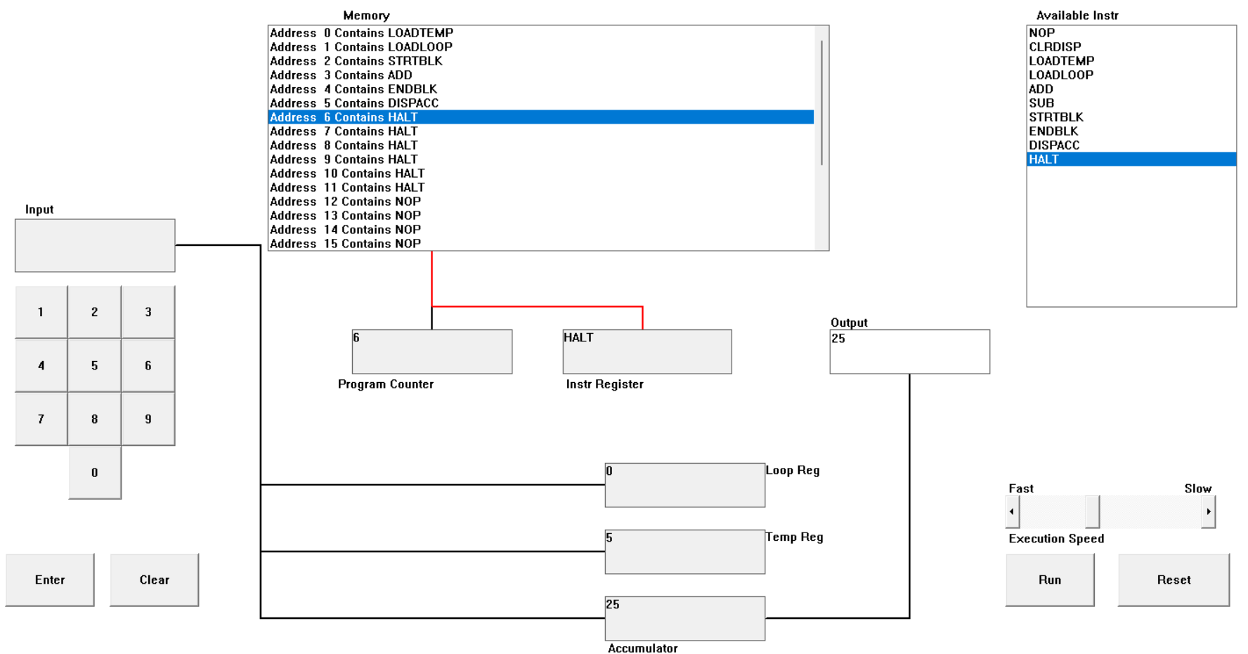

Execution Trace by Program Pointer
Here is a detailed breakdown of how this revised program yields the correct answer of 25:
- Pointer 0: LOADTEMP 5
The program turns on the keypad for the first entry. If you enter 5, this value is transferred into the Temporary Register, which stores the "multiplicand" (the number to be added repeatedly).
- Pointer 1: LOADLOOP is 5.
The program immediately requests the second input. With the second 5, this value directly loads into the internal Loop Counter Register. At this point, the accumulator remains 0.

- Pointer 2: STRTBLK
This command, "Start Block, is the beginning of the loop. The Program Counter knows to return to this exact address multiple times until the counter is empty.
- Pointer 3: ADD
This is the central arithmetic operation. It then enters a loop where the processor repeatedly adds the base value residing in the Temporary Register, 5, to the current value within the Accumulator, starting at 0.
- (Pointer 4:)
This command, "End Block," controls the loop. It then enters a loop during which it continuously adds the value holding in the Temporary Register, 5, to the value currently held in its Accumulator, with the addition initially taking place at 0.
- Pointer 5:
After the loop is finished, the program proceeds from the end block to this statement, which puts the final sum of 25 from the Accumulator to the output display of the simulator.
- Pointer 6:
It terminates the execution sequence and freezes the answer to 25 on the display screen.

